**Enguri Dam Foundation Deformation Process Under the Impact of Geologic Cracking and Water Reservoir Operating Mode**

**M. Kalabegishvili** Expert of Enguri Hydraulic Structures Tech. Sc. Dr., Prof. of Georgian Technical University, Department of Hydraulic Structures and Hydro Power Management 77 Kostava st., Tbilisi 0175, Georgia. E-mail: [Kalabegishvili@hotmail.com](mailto:Kalabegishvili@hotmail.com)

**Introduction**

Enguri HPP arh dam (H=271,5m ) foundation has a complex geologic structure. Major part of the canyon is of layerwise carbonated lower lime age formed by heterogeneous highly cracked limestones and dolomites. In terms of geological structure of foundation the most sizeable **geological sliding failure** (width 9 m ) exists on the right bank (**right bank failure**) and is filled with clay substance.

Clinometer measerments carried out during the entire construction (1969-1979) have revealed that in the process of dam and water reservoiur construction block **B** is more quick-responsive to technogenic processes block **A**, explained with the fact that cracking as a deformative (plastic) area mitigates tectonic as well as technogenic factors.

In 1972 (prior to filling the reservoir) a deformation gage was installed at the failure which has been used since then to conduct geophysical observations. Graphic records and general regularities of dynamics of dam canyon blocks located at differnt sides of cracking have been obtained, namely as a result of resevoir and dam construction blocks movements are reduced at some extent; water reservoir filling-drawdown annual mode has an effect on the blocks dynamics; 33-year-observation has revealed approximately 6.5 mm failure lateral expansion.

Right bank failure and main cracks in “dam–foundation“ 3D model (which has been processed using isoparametric elements) were modeled using special gap elements with compression and sliding stiffness determined by the normal and tangent values of elasticity module.

Reservoir filling-drawdown has an effect on blocks interconnectivity. Right bank failure screening the seepage flow and therefore represents the load surface during the reservour drawdown and causes the separation of the foundation blocks. During the reservour filling seepage body forces acting through the block A cause the approachment of the blocks.

Right bank sliding hazardous blocks have been identified according to geological cracking system, which is divided by failure. Based on the calculations the impact of theoretical value of reduction of deformation module of failure area on the stability capacity value has been assessed.

This study incorporates certain findings and evaluation of geophysical as well as theoretical measurements.

1. **Background**
   1. **Foundation Geological Structure**

Enguri HPP arch dam (photo 1) foundation has a complex geologic structure. Major part of the canyon is of layerwise carbonated lower lime ageand is formed by heterogeneous highly cracked limestones and dolomites. The major stuctural-tectonic component of the foundation is the geological sliding failure (constitutes part of

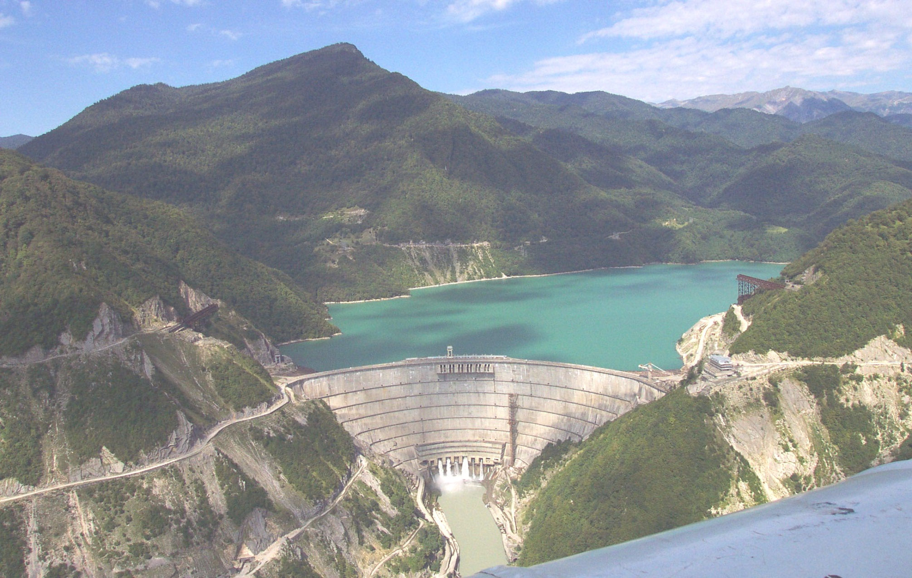

Photo 1. Arch dam Enguri HPP.

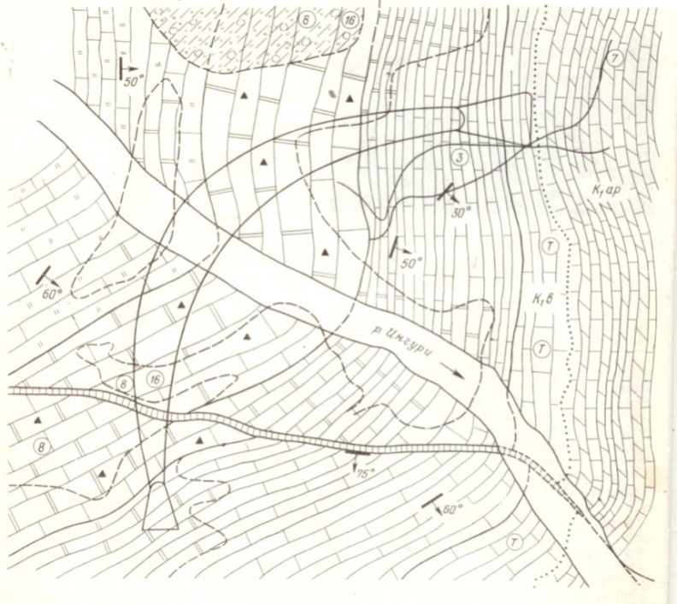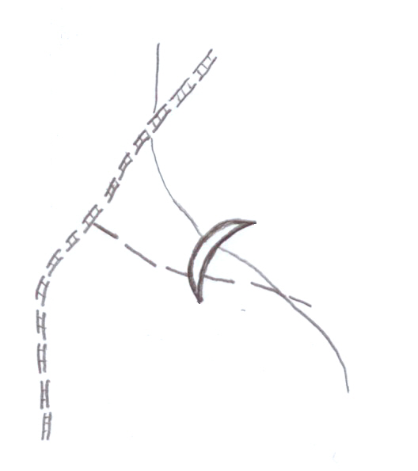

Ingrishi failure

**Arch Dam**

Right bank **failure**

Right bank Failure

**Arch Dam**

r**. Enguri**

Fig. 1.1 Tectonic scheme of dam foundation. 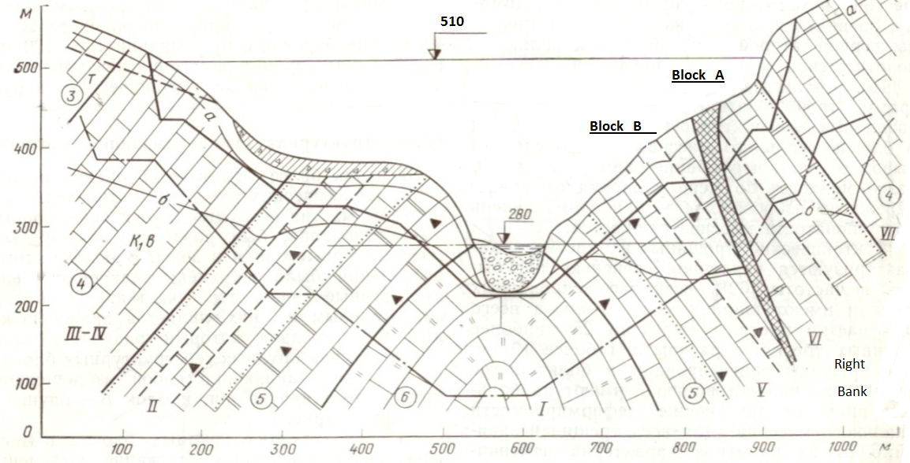

Fig. 1.2 Geological cross section.

Ingrishi big failure (fig. 1.1) of the right bank, which lies almost in parallel with the river and drops at the side of the slope 60-700 (fig. 1.2). Failure sliding amplitude vertically is 100 meters and horizontally is 80 meters.

Failure area capacity on the surface is 9 meters decreasing in the depth to 1-2 meters. It is filled with the dolomitic sand, calcites, gravel and clay substances. Right bank failure devides dam foundation into two major structural blocks **A** and **B**.

Geologic-tectonic development of hydrosystem has undergone two stages: upper Pliocene – average geologic quarter and Holocen upper quarter. On the both stages the area has undergone arching development (typical for Caucasus Mountains). Nevertheless, at the first stage along with the general arching, intensive differential movement of structural blocks of rock canyon (devided into the first and the second level crackings) has been also observed. Under these conditions, the movement amplitude reached hundreds of meters and certain blocks swelled obliquely. On the second stage common arching rate and the arch swelling volume have increased, though the blocks differential movement has stopped. The arch swelled as a whole area.

The last findings were particularly important for the engineering-geological estimaition of the dam foundation. Right slope of the dam leans upon two structural blocks of the foundation which are separated by the tectonic ruptures. The importance of this issue raised the necessity of continuing the instrumental investigation of the foundation. (Ostrovsky clinometer, quartz deformation gauge, hydrostatic level meter).

* 1. **Geophysical Investigations.**

During construction and operation of the dam, instrumental studies (clinometer, hydrostatic level meter, and quartz deformation gauge) were conducted by Georgian Institute of Geophysics through the entire construction process in 1969-1979. Eight major stages have been revealed with respect to the blocks deformation that was reflected in the clinometer results [1,2,3] (Fig. 1.2.1).

1. I stage – processing of foundation pit (at the depth of 50 m) caused considerable decompression of the foundation followed by the foundation arching - development of artificial arch. As a result, right side of block B deviated in the direction of the failure, while the left side deviated in the opposite direction. Block A also deviated in the direction of the failure.
2. II stage – foundation regained its initial condition with respective deviations as the weight of concrete in the pit reached the weight of the excavated soil.
3. III stage – construction tunnel was blocked and the energy downstream reservoir (capacity 400000 m3) formed at the downstream. As a result, both sides of block A and block B turned to the river causing foundation bending.
4. IV stage – block B deviated in the direction of the upstream after the filling of the bottom layer of the reservoir.
5. V stage – dam load increased along with the increase of the water volumes in the reservoir, correspondingly increased dam’s effect on the foundation, followed by the northeast displacement of A and B blocks.
6. VI and VII stages – A and B blocks turned towards water reservoir and river after the water level in the reservoir reached relatively upper point and the load increased.
7. VIII stage – deviation vectors regained natural - southeast direction after the water lever in the water reservoir reached design point and became stable and the deformation process caused by the load increase was practically stopped.

During the construction of dam and water reservoir block B was more quick-responsive to the technogenic factors than block A, explained with the fact that failure as a deformative (plastic) area mitigates tectonic as well as technogenic factors. Averaging vectors of the inclination vectors shown on the figures represent equivalent vectors, which can be divided into constituents deferential tectonic and technogenic factors. Directions of inclinations at II, V and VIII stages correspond to the technogenic factors with the least constituents.

In 1972 (before filling the reservoir) a deformation gage was installed at the failure which has been used since then to conduct geophysical observations (Photo 2). The deformation gauge (length 22.5m) is placed on the side of downstream (in 100 m distance from the dam) and horizontally crosses the failure. One end of the gauge is fixed to the block A and the other loose end is placed on the block B base.

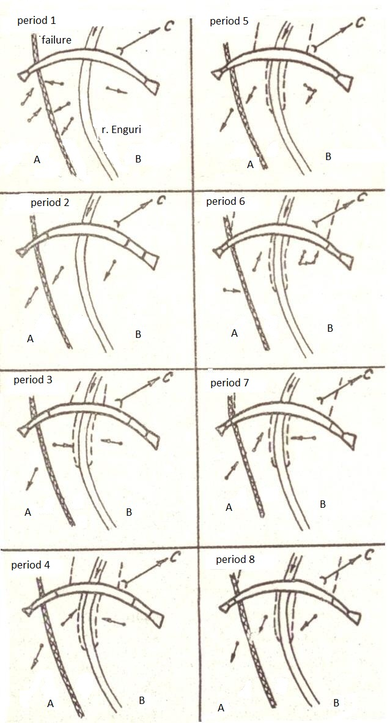

Fig. 1.2.1 Deviation vectors direction under different construction stages.

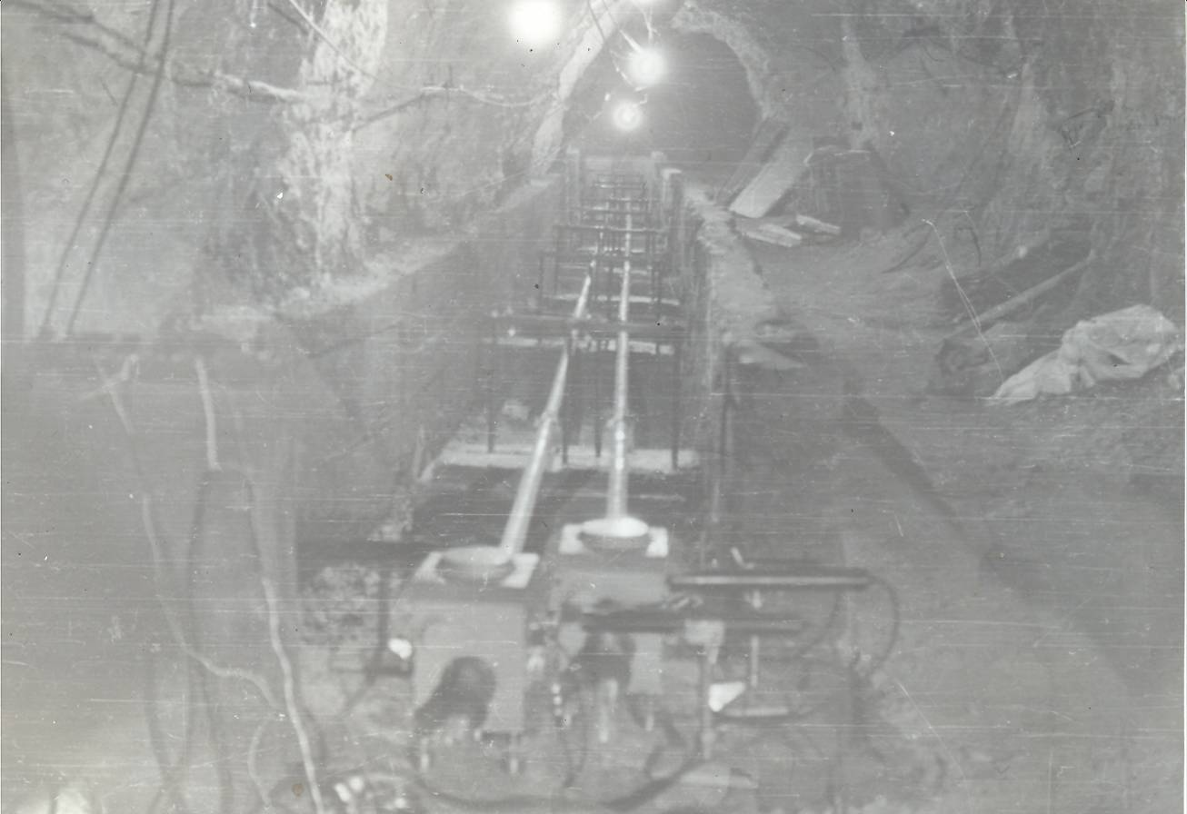

Photo 2. Quartz deformation gauge on the failure.

Graphic records and general regularities of dynamics of dam canyon blocks located at differnt sides of failure have been obtained fig. 1.2.2 , 1.2.3 .

* as a result of resevoir and dam construction blocks movements are reduced at some extent;
* water reservoir filling-drawdown annual mode affects the blocks’ dynamics;
* 33-year-observation has revealed approximately 6.5 mm lateral expansion.

1

9

7

4

7

5

7

6

7

7

7

8

7

9

8

0

8

1

8

2

8

3

8

4

8

5

8

6

8

7

8

8

8

9

9

0

9

1

9

2

9

3

9

4

9

5

9

6

9

7

9

8

9

9

0

0

0

1

0

2

0

3

0

4

0

5

0

6

0

7

2

8

0

3

2

0

3

6

0

4

0

0

4

4

0

4

8

0

5

2

0

0

.

0

1

.

0

0

.

5

1

.

5

2

.

0

2

.

5

3

.

0

3

.

5

4

.

0

4

.

5

5

.

0

5

.

5

6

.

0

6

.

5

7

.

0

ì

ì

H

,

ì

ã

î

ä

û



Fig. 1.2.2 Right bank failure lateral expansion (during 1974-2007) according to the

quartz deformation gauge data.



Fig. 1.2.3 Right bank failure lateral expansion (during 2000-2010).

1. **Foundation stability analysis using “Dam Foundation” system 3D model.**

This study is aiming at elaborating of a mathematic model using static-seepage coupled schemes and analyzing the following issues:

* Impact of water reservoir filling-drawdown rate at the blocks movements based on the geophysical investigations results;
* Seepage mode parameters of the slope under water reservoir rapid (1-3 m/day-night) filling-drawdown taking into account geological failure;
* Impact of material deformation module on the stability capacity (K) resulted from the 6,5m failure expansion.

Below is the examination of the issues raised above using “dam foundation” system 3D model.

* 1. **“Dam Foundation” System 3D Model**

For the purposes of the assessment of the issues raised above “dam foundation” system 3D model have been elaborated. For the approximation of the dam and foundation space isoperimetric elements have been used and the failure surfaces have been modeled using special gap elements (Fig. 2.1.1).

Right bank sliding hazardous block has been identified according to geological cracking system, which is divided by failure (Fig. 2.1.2). Physical-mechanic characteristics of cracking system have been determined according to the design values and variation of deformation module of the failure material.

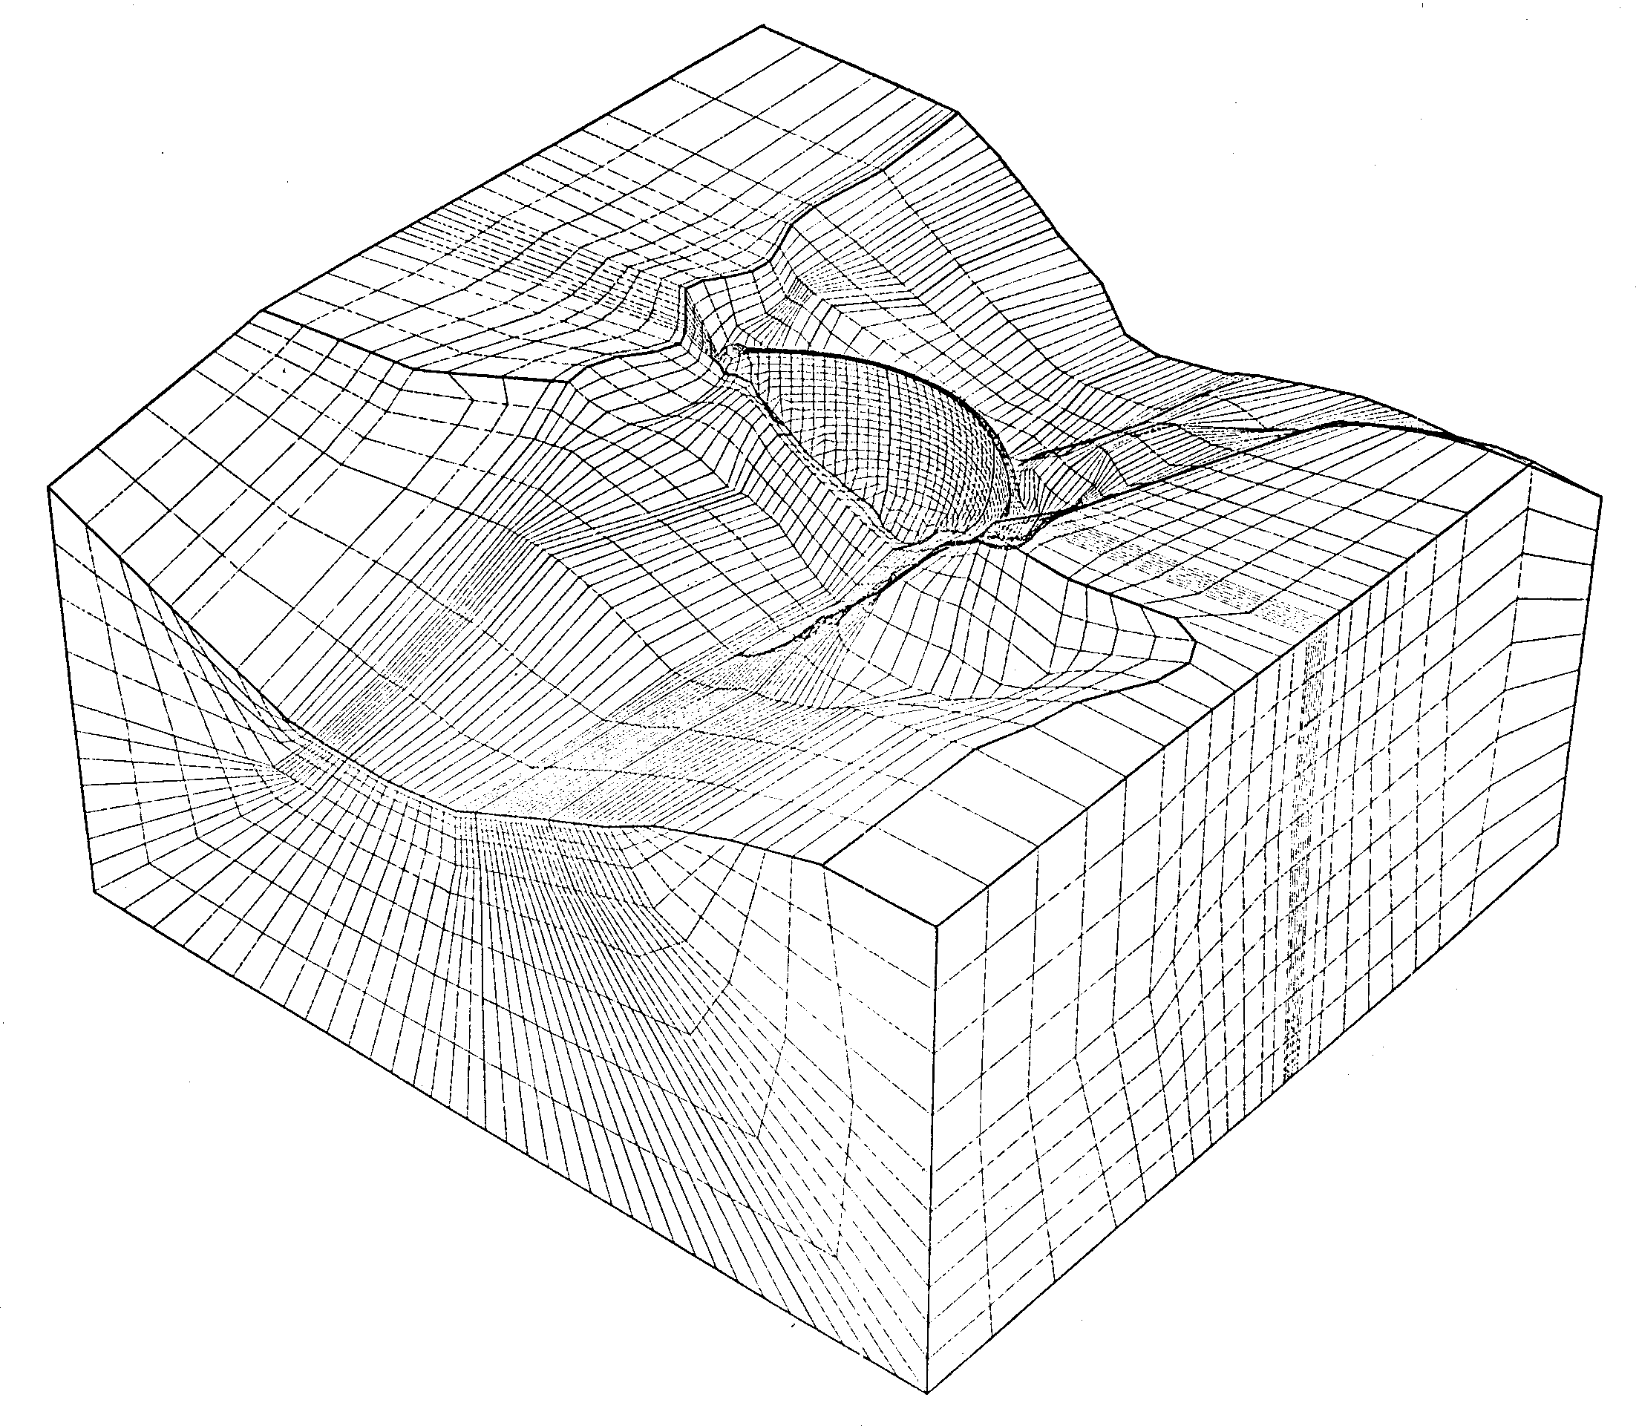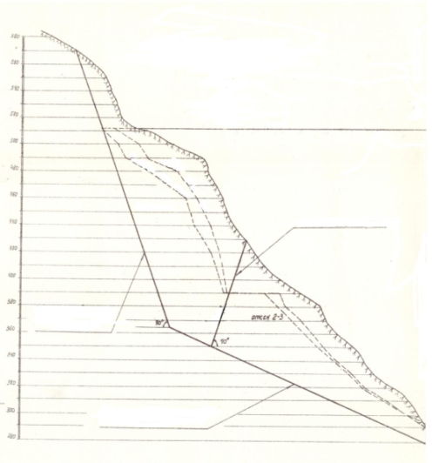

sliding surface

failure

abutment

right bank

Fig. 2.1.1 “Dam Foundation” System 3D Model. Fig. 2.1.2 Right bank supporting blocks.

* 1. **Impact of Water Reservoir filling-drawdown**

Seepage pressures distribution on the failure and the impact on the foundation **A** and **B blocks** have been estimated during water reservoir filling-drawdown within the level range of 410-510 m. Pressure distribution in the foundation canyon was estimated according to the isoperimetric pressures results. It has been estimated that the failure is considerably screening the seepage flow [4], resulting in the following outcomes:

* In the process of water reservoir filling ( fig.2.2.1, during nonstationary mode) higher values of seepage flow gradients are observed at **block A** (compared to block B) which cause failure compression (small sections according to deformation gauge data fig. 1.2.3).
* On the contrary, in the process of water reservoir drawdown (fig.2.2.2) excessive seepage body forces are observed at **block A** (compared to block B). Under such conditions failure becomes a load surface



1

1

**section 1-1**

**a)**

**b)**

1

1

nonstationary

steady regime

Fig. 2.3.1. Seepage gradients in

canyon during reservoir filling:

a) nonstationary regime (starting period);

b) steady regime.



1

1

**section 1-1**

1

1

nonstationary

steady regime

**a)**

**b)**

Fig. 2.3.2. Seepage gradients in

canyon during reservoir drawdown:

a) nonstationary regime (starting period);

b) steady regime.

* for the **block B** (which is the dynamic block of the foundation), causing increased load on **block B** as well as separation of blocks. This is shown as larger sections in fig 1.2.3 according to deformation gauge data.
* Increased filling-drawdown velocities increase load on failure and correspondingly affect blocks distance.
  1. **Stability Analysis**

Factor of stability on the sliding surface has been estimated according the following formula [5]:

Whereas, **ταc**-calculating resistance at material on sliding; **;**  - normal stress on failure surface; according to geological studies ; **τα** - shear stress in failure area.

Consequently, reducing of the failure material deformation module will cause respective decrease in strength capacity.

Gap elements, characterizing by normal and shear stiffness, are determined by normal and tangent values (**En, Et,** ) of elasticity module.

Lateral expansion of the failure is causing material decompression and relates to its elasticity module decrease. Therefore the impact of this process has been considered in accordance with elasticity coefficient variations and the following formula has been applied [4]:

Whereas, **σα**- normal stress; **h1**-width of the examinable layer; E and - material deformation module and represents Poisson coefficient according.

Based on the above formula current value (whereas **S** = 6,5 mm) of the deformation module equals (whereas **E0** is initial design value).



The upper 100 m layer of the arch dam (where normally ultimate arching load develops) leans upon the A block, thus diminishing the suppressing effect of the dam. Based on the above assumptions, it is reasonable to apply measurement results one certain section of failure to the bottom of the B block.

**Et**  varied through the calculation as the study is aiming at estimation the effect of deformation module decrease in the failure area on the shear stress and **K** value.

According to calculation:

- in the first series **Et=E0*, K=2.05;***

- in the second series **; *K=1.92.***



**Conclusions**

1. On the right slope of the Enguri HPP arch dam foundation exists Ingrishi massive tectonic failure which divides foundation into two large structural blocks. According to the long term complex geological-structural and geomorphologic studies at the first stage (upper Pliocene) the examining area has undergone intensive differential movements, at the second stage block movements reduced and the canyon swelled as a whole arch, which served as a precondition for designing a dam. Processes accompanying the construction and operation phases had an impact on the deformation of the blocks. As of today all processes are stabilized.
2. During the construction of dam and creation of reservoir block B was more quick-responsive to the technogenic factors than block A, explained with the fact that failure as a deformative (plastic) area mitigates tectonic as well as technogenic factors. Based on this assumption, failure lateral expansion is mostly caused by the movements of block B.
3. Following the data collected from the quartz deformation gauge tensile stress has been observed at the cracking until 1978. Compression stress has been observed periodically only during heavy precipation, under the impact of hydrostatic and seepage pressures in the cracks. In 1978-79 compression stress was developed at the failure during the water reservoir filling.
4. Deformative measurements (verified by the theoretical investigations conducted at 3D model) revealed that water reservoir operation has a considerable impact on deformation of the foundation. Failure is considerably screening the seepage flow, as a result:

* In the process of reservoir filling excessive seepage body forces are observed at block B (compared to block A) which cause failure compression. According to the deformation gauge measurement results it is tied with approaching of blocks.
* On the contrary, in the process of water reservoir drawdown excessive seepage body forces are observed at block A (compared to block B). Under such conditions failure becomes a load surface for the block B ( which is the dynamic part of the foundation) causing separation of blocks.
* Increased filling-drawdown velocities enhance the seepage forces and correspondingly affect blocks distance. Unsteady seepage mode observed at the bank is reflected on the inertia of the blocks approaching-separation. Significant seepage forces (according to gradients) are developed in the upper layer of the slope and are declining in depth. Based on this assumption deformation gauge data basically reflects only the upper layer of the blocks.

1. Foundation response to filling-drawdown is not lineal-deformative. The process is accompanied with the residual deformation. Non-lineal development includes elastic and as well as plastic deformations – sliding (which if viewed geologically corresponds to the Burger model).
2. During the operation period (according to 33-year-measurement results) failure lateral expansion equals 6.5 mm. Before regulated reservoir operation (1974-1984) failure annual expansion was 0,23 mm/y, during 1985-2007 – 0.14 mm/y and during the entire period (1974-2001) - 0,2 mm/y.
3. According to the measurement results reducing of reservoir drawdown depth decreases the lateral expansion rate, thus having positive impact on the foundation deformation. The above information together with monitoring results should be considered during operation process.
4. Lateral expansion is accompanied by reducing of material deformation module (verified by geophysical measurements and according to theoretical calculation is 14%) which causes 9% decline of foundation right bank stability capacity (under the effect of the major operating load) which equals to K=1.92 and complies with safety standards.

**References**

1. **Mastitski A., Kereselidze C., Abeshidze V.** Geostructural specifics foundation of Enguri arch dam and geological intrpretation clinomitars rezults. Geologic geophizic reserchis Enguri HPP region. Tbilisi 1981, pp. 147-165.
2. **Savich A., Bronshtein V., Ilin M., Stepanov V.** The safety of large dams in areas of high geodinamical hiard. Geodinamical studes of large dams. (Proceedings of International Seminars). Tbilisi 2002, pp. 11 - 19.
3. **Balavadze B., Abeshidze V.** Basic rezults of geofizical monitoring of deformational processis inthe region of inguri HPP. Geostructural specifics foundation of Enguri arch dam and geological intrpretation clinomitars rezults. Geologic geophizic reserchis Enguri HPP region. Tbilisi 1981, pp.34 – 39.
4. **Kalabegishvili M.** The analysis of parameters defining Inguri waterpower plant water-storage reservoir impoundment. Hydro 2007. New approaches for a new era. 2007, Granada, Spain.
5. **СПРАВОЧНИК** проектировщика бетонных сооружений гидроэлектростанций. Москва «Энергоатомиздат», 1985.(Russian)

### The Author

**M. Kalabegishvili.**  Doctor of science, professor of Georgian Technical University (GTU, Department of Hydraulic Structures and Hydro Power Management), Tbilisi, also expert of Enguri HPP.

Mr. Kalabegishvili graduated from Georgian Technical University. In 1984 he defended his Ph.D. thesis and in 1998 - doctor’s thesis.

He participated in the following scientific and engineering projects:

* USAID – Burns & Roe (1998), AED (2000), DAI(2002) - projects on hydropower objects in Georgia and Azerbaijan;
* JACOBS Ltd (London), (IDCDP project, 2003-2004) – expertise high-head ears and rock-fill dams: Sioni, Algeti, Zonkari.
* ISTC (2002-2005) – new design of high-pressure prestressed reinforced frame;
* Rehabilitation of Enguri HPP pressure tunnel (2005), Ortachala HPP and Shaori HPP dams (Georgia, 2005-2006);
* In association with designing company Kocks Consult GmbH, Consulting Engineers - Gori and Ricoti highway tunnels (2007- 2010) in Georgia
* Zinvali HPP – rehabilitation of spillway dam (2010).

He has scientific publications in the field of static, dynamic and seepage analyses of hydraulic structures.